**Recurrent Neural network**

**Introduction**:

The objective of this report is to explore various hyperparameters and their level of impact on the performance of the sentiment analysis model by making changes to the pre-existing IMDB dataset.

**Methodology**:

Initially IMDB data set is trained by the model with 25,000 training samples. Restricted the movie reviews to top 10,000 common words and cut off review after 20 words. Embedding layer takes input of shape (1000,64). Conducted many experiments by changing one hyperparameter at a time and observed changes in the performance of modified model

**Analysis**:

|  |  |  |
| --- | --- | --- |
| Model | Accuracy (%) | Validation Accuracy (%) |
| Main Model | 88.63 | 74.54 |
| Cut-off reviews | 94.88 | 85.64 |
| Restrict training samples to 100 | 100 | 55 |
| Increase of validation samples to 10000 | 88.7 | 75.41 |
| Decreasing top most common words | 85.72 | 74.74 |
| Pretrained Model | 100 | 56.24 |
| Best training sample(20,000) | 87.93 | 76 |

**Results**:

Increase in the length of cut off reviews from 20 to 150 results in increase in the information amount for each review that let the model to learn more relationships between the text and the sentiment of review. As a result, accuracy increases. Also, we see that validation accuracy has been increased significantly to **85.64%**. This says that longer reviews made the model to learn useful patterns and features.

Decreasing the training samples to 100 will make the model overfit to the training data. Therefore, accuracy has been increased to 100%. This will not perform well on the unseen data as model is unable to learn useful patterns and hence validation accuracy has decreased drastically to **55 %**.

Increasing the validation samples to 10,000 will let the model to evaluate the performance more accurately. There is slight increase and decrease in validation accuracy and accuracy respectively because there might be a little overfitting to the training data and increasing the validation samples has made it better.

Decrease in the number of top common words decreases the performance as less information available to the model. However, there was a slight increase in the validation accuracy. This would be because there may be a chance that model is focusing only on the most important words and therefore the performance is better on validation set.

Pretrained word embedding

Generally, pretrained model increases the performance because it contains information that is learned from large datasets that enables the model to learn meaningful features of the texts. However, in our example, since we have given only 100 training samples which are not enough to utilize the pretrained embedding, validation accuracy has decreased to **56.24%**

Changing training samples size:

Increasing the number of training samples decreases the accuracy as the model is unable to capture all the patters but validation accuracy increases as more data is needed to learn useful patterns. After a certain point validation accuracy starts decreasing due to overfitting. Sample size of **20,000** is seen to have highest validation accuracy of **76%** with better training accuracy **87.93**

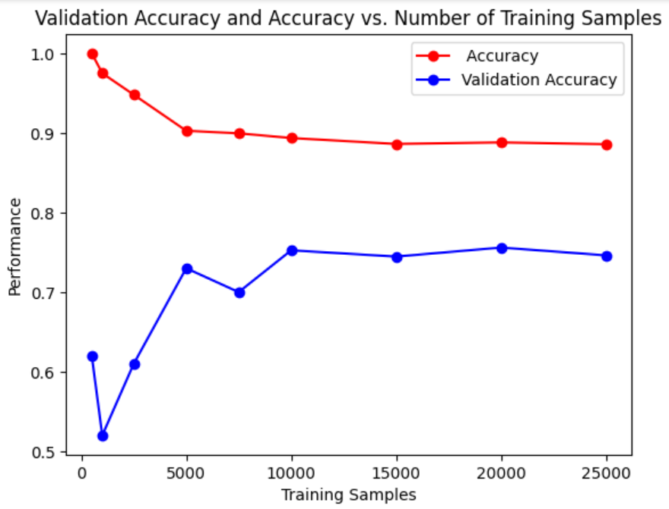

**Conclusion**

In this experiment, it is observed that hyperparameter **cut off review** shows major impact on the performance of the model and considered as the best modified model with accuracy 94.88 and validation accuracy of 85.64. Other hyperparameters such has training sample size; validation sample size and top common words has minimal impact. Pretrained model with enough training sample would be better for the better performance.